UNITS OF TIME
KS1 – 2001 Paper
1.
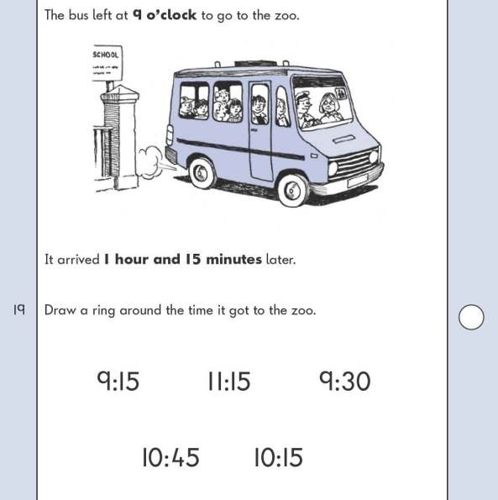
KS1 – 2005 Paper 2
2.
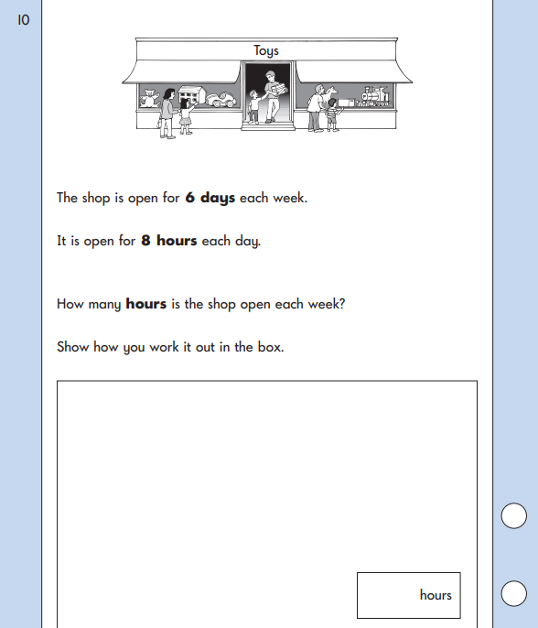
KS1 – 2022 Paper – Reasoning
3.
